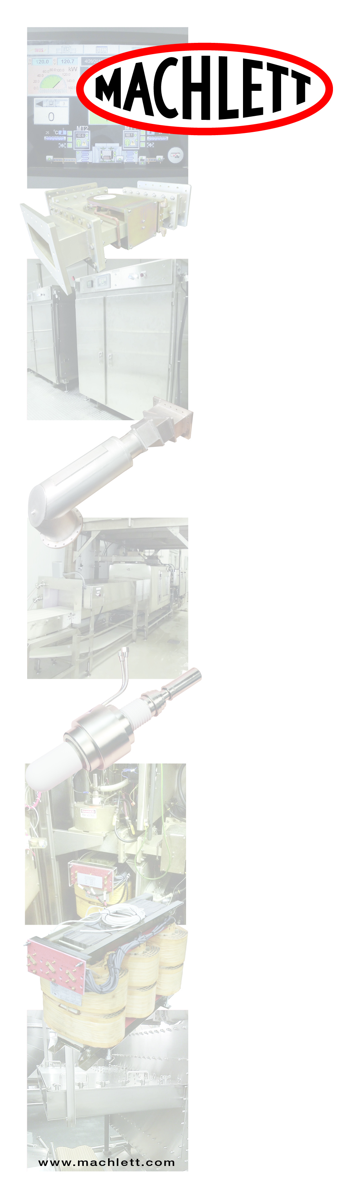

**Effects of Under- and Over-tempering of Products on Various Processes**

|  |  |  |
| --- | --- | --- |
| ***Process*** | ***Effect of***  ***Under-tempering*** | ***Effect of***  ***Over-tempering*** |
| ***Slicing*** | Equipment failure  Curled and shattered slices  Excessive fines | Incomplete slices (strings)  Smeared slices  Ragged edges |
| ***Dicing*** | Equipment failure  Excessive fines  Broken dices | Incomplete dices (strings)  Excessive product tearing |
| ***Pressing*** | Equipment failure  Shattered meat  Reduced surface damage | Squeeze-out (blood loss)  Ragged surface |
| ***Grinding*** | Equipment failure  Shattered meat | Blood loss  Excessive tearing (becomes mushy when cooked) |
| ***Controlling***  ***temperature***  ***at patty***  ***former*** | Equipment failure  Lack of weight control  Incomplete forming  Lack of patty bind | Lack of weight control  Ragged edges  Sticky patties  Wasted refrigeration |
| ***Controlling***  ***temperature***  ***of sausage***  ***blend*** | Unsatisfactory protein extraction  Unsatisfactory stuffing  Smeared appearance | Protein loss  Wasted refrigeration |
|  |  |  |

**Penta Labs/Machlett Microwave** 9740 Cozycroft Ave., Chatsworth, CA 91311 Office: 800-421-4219 ext. 205

**Industrial Microwave**

**Systems & Service**

